Zuzana Čepcová, Peter Dušička, Ľudovít Možiešik

Interaction of Navigation and Hydropower Plants Operation

The energy operation has a considerable impact on navigation, in particular, in derivation schemes of regulatory hydropower plants (HPPs), if the derivation canal is used for navigational purposes. This is due to sudden changes of flow through HPPs, a by-product resulting from use of these sources for providing ancillary services to the electricity supply system. The purpose of this research is to determine the critical margin of manipulation with HPP, or, for that matter, to propose measures that would harmonize the „contradictory“ interests of navigation and energy industry.

Key words :Shock waves, navigation, regulatory hydropower plants



**1. Introduction**

Objects of each water structure (WS) should be designed to serve their purpose, and, simultaneously, for their respective operations (navigation, energy or weir operation) to influence each other only within the set borders without restricting their functionality.

Traffic of vessels on waterway is, to a considerable extent, influenced by the hydraulic parameters of water flow. A safe movement of vessels on flowing water in the canal and its maneuverability depends on the changed flow rate volume during HPP manipulation, the time course of manipulation, the surface slope and the direction taken by the moving vessel in the canal. Vessels can be adversely affected by water flow with any of the following consequences:

* Collision with another vessel,
* Crush into WS object, bank or bottom of waterway followed by the tearing-up of ropes binding the vessels in array,
* Breaking loose of moored vessel.



Fig. 1: Scheme of interaction between energy management and navigation

**2. Issues analysis – methodology of solution**

Sudden change of flow (steep load or shut-off of turbines, excessive increase or decrease of flow), emergency failure at HPP, wrong manipulation at weir field gate or overflow outlets, all give rise to shock waves on the waterway. These are dangerous for both sailing and moored vessels.

The wave’s impact on the vessel movement depends mainly on the shock wave’s parameters (surface slope, height, length, advancing velocity), the vessel’s parameter, the direction taken and the vessel’s velocity on collision with the wave. That impact should be considered and assessed. The assessment can be divided into 3 steps.

**2.1 Step 1: The course of water level in the canal**

Step 1 in the hydrodynamic model must check the water level regime in the derivation canal for required HPP manipulations. The input data are the parameters of energy operations – in particular, flow rate changes in time. The water level regime must be designed in a view of unsteady flow that is characterized by time change of flow rates and water levels in the derivation canal’s different profiles.

For the derivation canals of the Váh Cascade, the company Etirs together with the Department of Hydraulic Engineering, Faculty of Civil Engineering in Bratislava, developed the 1-D hydrodynamic model. That was gradually calibrated as based on „in situ“ measurements. The model’s output also includes the surface slope of the specific derivation canal section as arising from different scenarios of simulated normal HPP operations, its corresponding value of the waterway’s cross-sectional area; the said parameters are used in the following solution.

**2.2 Step 2: Safety assessment of moving vessel in the canal**

Step 2 must consider the impact of waves caused by energy operation on moving vessels by computing the force impact of flow (e.g. Partenscke methodology), and monitor the critical section – the vessel’s route on the tilted surface of the wave from the point of encounter.

The movement can be as follows:

* **Slowed down –** the velocity of a vessel at sail against the shock wave’s slope gradually slows down, due to gravitation, to the point of possible loss of maneuverability, and the vessel is subsequently being drifted by the wave (secure velocity of the down-slowing movement should be no less than 0 m.s-1). The computation makes use of the formula as follows(1):

** (1)

* **Accelerated** – the vessel is moving in the direction of the wave’s slope; the velocity can accelerate to the point of its absolute velocity being equal to the velocity of the flow; the vessel loses maneuverability and is being drifted uncontrollably. The computation makes use of the formula as follows (2):

** (2)

where:

|  |  |
| --- | --- |
| *Vinit* | - the vessel’s uniform velocity prior to wave encounter |
| *Iw* | - surface slope /wave |
| *xx* | - the section taken by the vessel on the wave’s tilted surface |
| *Gv* | * vessel`s weight |
| *G* | - gravitational acceleration |
| *Clat* | - total resistance coefficient |

The wave’s advancing velocity and the vessel’s velocity can be used to arrive at the period of impact of the slope force, as well as the distance taken by the vessel on the wave’s tilted surface. The output of the Step 2 is the dependence of the vessel route distance on the wave’s tilted surface and the vessel’s immediate velocity. At this stage, the vessel’s relative safety can be measured based on its maneuverability.

**2.3 Step 3 – Analysis of results**

The last step involves processing and evaluation of the results. Ultimately, these can be used for corrections of the parameters of energy operations, to keep the navigation safe and secure.

This is one of the ways to seek the borders of coexistence between regulatory energy operation and safe navigational operation at WS.

**3. Application: WS Drahovce – Madunice**

The methodology of assessing navigation’s impact on canal HPPs operation was applied in order to be verified at WS Drahovce – Madunice. This WS is constituent of the Váh Cascade, which was built chiefly for the purpose of energy operation, although one portion of the Cascade was considered for navigational use, as well. For a prospective use, the Váh Waterway (in AGN Agreement referred to as E 81 waterway of international significance of the class VIa in the section Komárno – Sereď and the class of  Va in the section Sereď – Žilina) could be linked to the Danube Waterway. Navigability is divided in several stages. Currently, the section Sereď – Komárno is partially navigable. The section up to Sereď is essentially navigable in the river scheme; in the upstream direction of Madunice navigation enters the derivation canals of the Váh Cascade.

The first canal HPPs of the Váh Cascade were built as direct flow HPPs, later semi-peak up to peak HPPs. Most recently, the provision of ancillary services has been added to the service list of the Váh Cascade’s HPPs. However, scheduled navigation would place restrictions on the previous HPP operation (and most likely necessitate additional regulatory energy sources for Slovakia’s electricity supply system).

Canal HPPs make up for a large portion of the total installed capacity of the Váh Cascade – as much as 60.35 % without considering the pumped-storage HPP Čierny Váh and the pumped-storage part of HPP Liptovská Mara.  This makes the solution of navigation’s impact on canal HPPs operation highly topical.

Additionally, the choice of WS Drahovce – Madunice for verification of methodology was also due to the abundance of existing support –„in situ“ measurements made on the given section.

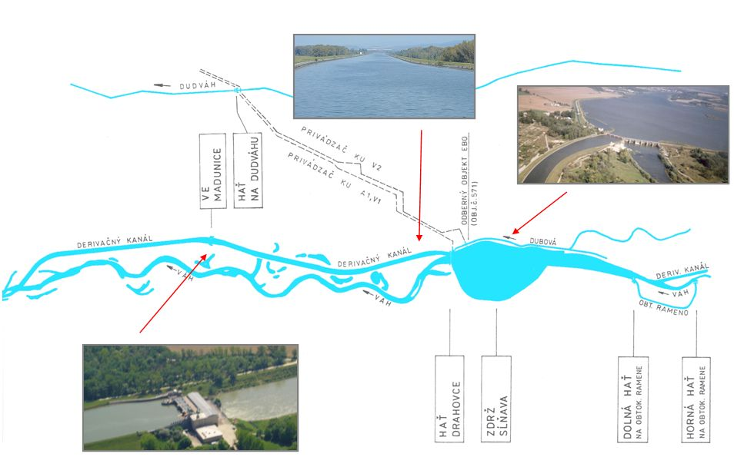

HPP Madunice

WEIR

Drahovce

RESERVOIR

Sĺňava

INTAKECANAL

Fig. 2: WS Drahovce Madunice – reservoir, intake canal and HPP Madunice

In the last five years, the Hydraulic Engineering Department conducted „in situ“ measurements of water levels for diverse operational regimes of HPP Madunice. On that basis, it was possible to calibrate and verify the hydrodynamic model of water flow in the derivation canal used for the solution. That proved a good starting point for making realistic computations of the impact of arising waves on the navigation. The solution involved the intake canal that could be navigable without substantial building intervention (requiring, essentially, only adjustment of terminal profiles – inflow from reservoir to intake canal in Drahovce, Madunice lock).

The normal operation modeling of HPP Madunice focused mainly on start-up operation (range of discharges trought HPP and diverse water levels in the Drahovce reservoir). The HPP operation start-up generates decrease of water level at the termination point of the intake canal and a negative wave advancing upstream in the canal, with the ultimate decrease of canal water level.

Emergencies in HPPs usually occur under unforeseeable circumstances (network fallout, defects of technology); HPP is thus unable to release discharge. Consequently, HPP is immediately shut off. The resulting positive back wave is first suppressed in an upstream regulation lock, and then advances on the intake canal.



Fig. 3: Advancing wave in intake canal, frontal wave movement in the canal at selected times



Fig. 4: Advancing wave in intake canal at HPP emergency shut-off

The monitored route distance of the vessel (search for a safe velocity range) moving on the wave’s tilted surface depends on the

parameters of the wave generated by HPP operation, waterway parameters, the vessels inherent parameters and its initial velocity.



Fig. 5: Immediate velocity of typical vessel on the wave’s tilted surface

Fig. 6: Immediate velocity of typical vessel on the wave’s tilted surface (Most moderate scenario)

**4. Conclusion**

The application of the methodology in the WS Drahovce – Madunice system (for typical vessel: full-powered motor cargo vessel Europa) in the intake canal resulted in the following:

* at normal HPP peak operation – the vessel is impacted by the wave regime, yet, if complying with the set recommendations of navigation operation (minimum recommended velocities

based on computation), the vessels will not be dragged-down or drifted.

* At emergency (during higher discharges trought HPP) – navigation is seriously jeopardized. Possible coexistence of navigation and energy operation will necessitate replacement of the missing discharge through HPP by another structure (for instance, idle discharge).

Technical and organizational arrangements should be provided in the WS manipulation rules`, including the control room’s dispatching activity, displaying and monitoring of critical sections of the waterway, security instructions for the control room at emergency and navigation instructions.

The results of the application of the methodology in the specific WS include proposed measures in design (adjustments of construction) and, in particular, in operation (determination of limits of safe navigation operation and experimental prolongation of the start-up phase of energy operation to safeguard safe and real operation).

Described methodology is applicable in diverse stages of solving the interaction between navigation and energy operation – WS design, assessing impact of prepared navigation for existing energy operation or additional adjustment of operation parameters for existing WSs.

References

[1] čepcová, z.: Vplyv plavby na energetické funkcie regulačných vodných elektrární, Kandidátska dizertačná práca, SvF STU Bratislava, 2007

[2] ČÁBELKA, J., GABRIEL, P.: Matematické a fyzikální modelování v hydrotechnice, Československá akademie věd, Praha, 1987

[3] Manipulačný poriadok sústavy VD Drahovce – Madunice /schválený 10.03. 2000, platný do 31.03. 2005/

[4] MEDŘICKÝ, V.: Hydrotechnické stavby, Navrhovaní plavebních stupňů, Vydavatelství ČVUT v Prahe, 2000

[5] MOŽIEŠIK, Ľ.: Interakcia prevádzky vodných diel a plavby, Habilitačná práca, SvF STU Bratislava, 2003

**ADDRESSES OF AUTHORS**

Zuzana Čepcová, Ing., PhD., Slovak University of Technology in Bratislava, Department of Hydraulic Engineering, Radlinského 11, Bratislava, SK 813 68, Slovak Republic

Peter Dušička, Prof. Ing., PhD., Slovak University of Technology in Bratislava, Department of Hydraulic Engineering, Radlinského 11, Bratislava, SK 813 68, Slovak Republic, [peter.dusicka@stuba.sk](mailto:peter.dusicka@stuba.sk)

Ľudovít Možiešik, Doc. Ing., PhD., Slovak University of Technology in Bratislava, Department of Hydraulic Engineering, Radlinského 11, Bratislava, SK 813 68, Slovak Republic, [ludovit.moziesik@stuba.sk](mailto:ludovit.moziesik@stuba.sk)