Jozef Király, Iraida Kolcunová, Karol Marton, Roman Cimbala
Katedra elektroenergetiky, Fakulta elektrotechniky a informatiky, Technická univerzita v Košiciach

Dependence of dissipation factor of magnetic fluids by temperature

Abstract. The article deals about magnetic fluids based on a transformer oil and dependence of dissipation factor tgδ by temperature at different concentrations of these fluids. It also deals about influence of action external magnetic field to the behavior of this parameter.

Keywords: magnetic fluid, thermal dependence, dissipation factor, nanoparticles.

Introduction
Magnetic fluids are colloid solutions based on carrier medium and ferromagnetic nanoparticles, which are coated with surface active substance which is also called surfactant. Ferromagnetic nanoparticles performs role of carrier of magnetic properties in the magnetic fluid. The function of surfactant in these fluids is to set up homogeneously dispersion of nanoparticles in volume of fluid. We can talk about stabile magnetic fluids in case, when concentration neither distribution of magnetic nanoparticles is unchanged. Thus composed magnetic fluids can form equivalent of many conventional fluids used in electric engineering, engineering but also in medicine with added magnetic properties. [1].

Physical properties of magnetic fluids

Particles dispersed in magnetic fluid reaches usually dimension about 3 - 15 nm. Typical content of these particles in fluid is 10²³ m³. Following to size of these particles their behavior is like a mono domain, thus every of them behave like a independent dipole with size M_{d}=10⁹µ_{B} where µ_{B} is Bohr Magneton, therefore the smallest amount of electron magnetic moment. [2].
When we ignore interaction between nanoparticles, we can predict, that magnetic fluid will behave like a paramagnetic fluid so these behavior we can describe by Langevin function as shown in Figure 1. [3]
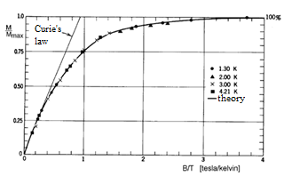
Figure 1. Langevin function [3]

In case when magnetic moments are bigger than magnetic moments of atoms of usually paramagnetic substances, we can talk about a superparamagnetic behavior. [2].

Magnetic fluid based on inhibited transformer oil
For production magnetic fluid for usage in high voltage devices it's possible to use mineral oil enriched with inhibitors. The role of surfactant performs oleic acid. These oleic acids are organic acids which are in group of higher olefin-carbon acids. Structural formula is shown in Figure 2. [4].
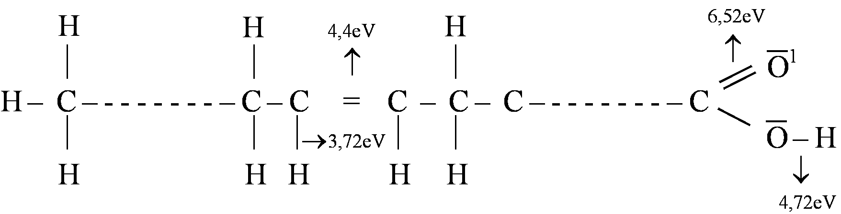 Figure 2 Structural formula of oleic acid [5]

As follows from figure 2, molecules of oleic acid are amphiphile. It means that they have a polar hydrophilic head and nonpolar hydrophobic part. This hydrophobic part is acid formed with long chain in case of this. Polar head will snap this long chain to magnetite nanoparticle, resulting in solvat cover (as shown in Figure 3.). The production of magnetic fluid is possible by process of precipitation, i.e. shrinking of soluble substance from solid dilution [2].
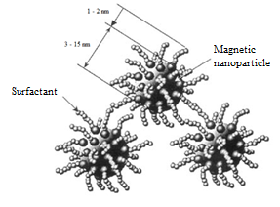

Figure 3. Nanoparticles of magnetite coated by surfactant [6]

For usage in electric engineering is interesting usage of these fluids like replacement conventional inhibited transformer oil. The main advantage should be improved heat conduction, what is caused by effect of thermomagnetic convection and with content of iron oxides. Thermomagnetic convection is based on fact, that magnetization of magnetic fluid rises with decreasing of temperature. Consequently, if the gradient of magnetic field is applied antiparallel to gradient of temperature, the flow of colder fluid is created to places with higher temperature. And there will be the fluid heated and this causes a more effective cooling [2].
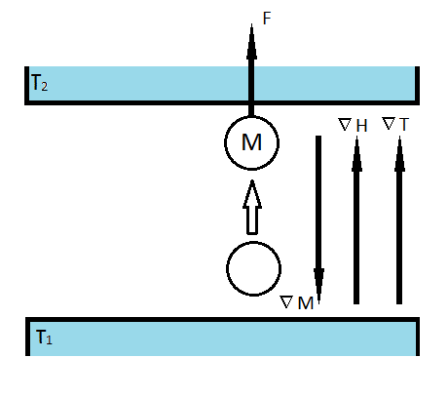
Figure 4. Thermomagnetic convection [2]

Condition for this phenomenon is presence of temperature gradient and magnetic field. For use in power transformer are conditions for thermomagnetic convection satisfied. The source of temperature gradient is heat produced by AC current in windings. Thus heat generated by winding and core of transformer creates in area inhomogeneous magnetic field temperature gradient. The velocity of transmission of heat from inside of power transformer to walls of the vessel and dissipation of heat to surrounding environment determines highest currents in the windings therefore in part determines a size and weight of power transformer for a given power.. Accordingly more efficient cooling could bring smaller dimensions of power transformers and less amount of cooling fluid. Equally important is decreasing of windings temperature, which can be up to 10% [7]. Limit factor is a viscosity of these used magnetic fluids, because too dense magnetic fluid will not get into every layer of oil - paper insulation system..
From view of electrical breakdown strength is also possible to think about positive impact magnetic nanoparticles. By degradation transformer oil begins releasing particles of sludge of microscopic size. These sludges get electrical charges what lead into formation of bridges, what cause electric breakdown. Presence of magnetic nanoparticles can partially reduce produce of these bridges, what should cause increasing of electric breakdown strength in partially degraded oils.

Power dissipation factor tgδ
Dielectric losses in nonpolar fluids are caused only by their conductivity, since in axis structure hasn't dipole moment. These dipole moments may lack also in case, if the dipole moments are canceled by the mutually interaction of these dipole moments. These substances are for example paraffin, benzene, carbon tetrachlorid etc. Mineral transformer oil is otherwise compound of nonpolar hydrocarbons, but in practice used oils includes small amount of polar components, what will be reflected with dielectric losses at low temperatures until with increasing frequency (see Figure 5.) [7].
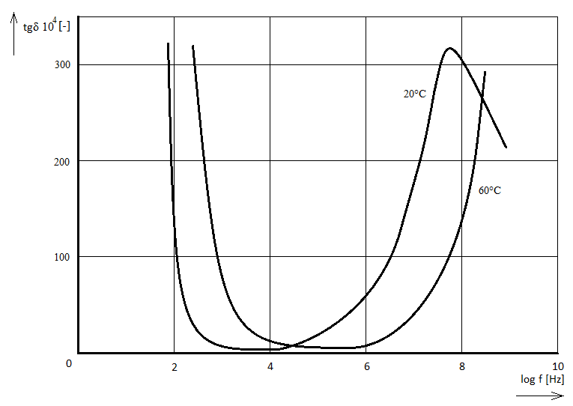
Figure 5. Dependence of dissipation factor from frequency at two temperatures

The decrease in first part of these characteristics is caused by conductivity losses. The dissipation factor decreases inversely to rising frequency in these parts. With rising frequency begins indicate losses caused by dipole orientation. Relaxing time is equal to inner viscosity of environment. By low frequencies that corresponded to longer time, the relaxation time of polarization is low and the orientation of dipoles is associated only with small power losses. With increasing frequency of field is also increasing speed of rotation of dipoles and this time is similar to time of relaxation. Losses are increasing and reaches maximum by frequency which is equal to:
- $f_{max}=\frac{1}{2}πτ$ [7]

By next increasing of frequency is time necessary for dipole rotation shorter than relaxation time. The result is that rotation of dipoles is delayed. Consequently this dissipation factor is decreasing. For higher temperatures, when the viscosity is lower, is the trace of dissipation factor moved to higher frequency. [7].
Dependence of dissipation factor can be expressed similarly. By low temperatures is dominant impact of dipole polarization. Influence by viscosity causes that dipoles can't move so the losses and dissipation factor are low. With increasing temperature is viscosity decreasing and dipoles can follow the changes of electric field. Therefore highest losses are at temperature in which relaxation time is equal to:

- $τ=\frac{1}{2}πf_{max}$ [7]

With further increasing of temperature, viscosity continues decreasing same like dissipation factor. But the losses will rise caused by rising conductivity. The higher frequency of electric field causes, that temperature must be higher to reach maximum dissipation factor.

Experimental base
Experiment was performed on sample placed in vessel made from PTFE in which was placed electrode system composite from Rogowski electrode system (see Figure 6.). External applied magnetic field was created by pair of permanent NdFeB magnets with magnetic induction 40 mT, which placement was perpendicular or in axis of electrode system. Distance between electrodes was set for measurement to 0,5 mm.
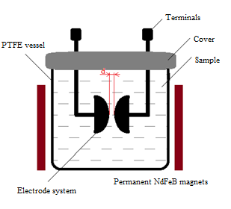
Figure 6. Vessel with electrode system and magnets

The measurement was realized by temperatures in range from 35 degrees Celsius up to approximately 100 degrees Celsius. The concentration of magnetic nanoparticles was between 0,185% and 2%. For comparison we used a sample of pure transformer oil.
Assignment of dissipation factor was made by parallel RC model. The capacitance and internal resistivity of sample was measured through the LCR meter. Usage of parallel RC model was determined by measuring frequency of LCR meter, which was default 1 kHz. For frequencies above 1 kHz we should use a serial model of RC, because for these frequencies is occurrence of skin effect possible.
- $\tan{δ=\frac{1}{ωRC}}$

Comparison of the measured characteristics
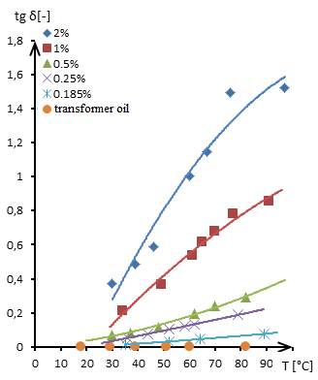
Figure 7. Thermal dependence of dissipation factor for different concentrations of magnetic fluid without applying external magnetic field

Dependence which is displayed in figure 7 points to the fact, that dissipation factor rises with increasing of temperature approximately linear. In general thermal, dependence dependent from contribution of losses from dipole polarization an from losses from conductivity. Conductivity of magnetic fluids rises with temperature and with concentration of magnetic nanoparticles. Higher concentration means higher conductivity, what causes bigger losses from conductivity and thus also higher dissipation factor. For comparison influence of external magnetic field to value of dissipation factor we're compiled graphical dependence for impact of perpendicular magnetic field with induction 40 mT, which is shown on figure 8.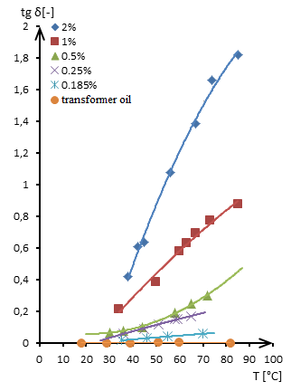
Figure 8. Thermal dependence of dissipation factor for different concentrations of magnetic fluid with applying perpendicular external magnetic field

The increase of dissipation factor is due to orientation of magnetic nanoparticles to direction of external magnetic field, what causes in sufficiently long time of action, formatting a clusters of these nanoparticles, what causes decreasing of mobility of particles between the electrodes. Analogy is applying external magnetic field in direction identical as direction of electrical field. These clusters are orientated in direction of electric field, what causes increasing mobility of particles between electrodes. Due this fact the value of dissipation factor is decreasing.

Conclusion
Task of these experiments realized on magnetic fluids was to demonstrate possibility of replacement conventional insulation liquids used in electric engineering with new component fluid. Important parameter of these colloidal liquids is a concentration of added magnetic nanoparticles, which considerably influences final properties of fluids. By high concentrations is possible to reach great thermal conductivity, but the result is due to high viscosity and high content of iron oxides not usable in power transformers. Therefore is necessary to find out, how many nanoparticles can increase the thermal conductivity and breakdown strength, without negative impact to dielectric losses. As it is shown in Fig. 7 and 8, the border between applicable and unusable liquid concentration is 0.5%. It should be noted, that impact of external magnetic field applying in two directions causes change of behavior of these fluids due to direction.

Acknowledgment

We support research activities in Slovakia / Project is co-financed from EU funds. This paper was developed within the Project "Centrum excelentnosti integrovaného výskumu a využitia progresívnych materiálov a technológií v oblasti automobilovej elektroniky", ITMS 26220120055 and project VEGA No. 1/0368/09.

Bibliographical references
- Wikipedia contributors: Ferrofluid [online]. Wikipedia, The Free Encyclopedia, 2011. Actualised 2011-04-23 [cit 2011-04-24]. Available on internet: <http://en.wikipedia.org/w/index.php?title=Ferrofluid&oldid=425514227>
- HERCHL, František: Štúdium elektrofyzikálnych vlastností magnetických kvapalín na báze transformátorového oleja: Dizertačná práca. Košice: SAV ÚEF, 2008. 87 p.
- TIRPÁK, Andrej: Elektromagnetizmus. Bratislava: Univerzita Komenského, Fakulta matematiky, fyziky a informatiky, Katedra rádiofyziky, 2004. 711 p. ISBN 80-88780-26-8.
- Wikipedia contributors: Oleic acid [online]. Wikipedia, The Free Encyclopedia, 2011. Actualised 2011-04-18 [cit 2011-04-20]. Available on internet: <http://en.wikipedia.org/w/index.php?title=Oleic_acid&oldid=424671632>
- MARTON, K. et. al.: Spatial Charges in Magnetic Liquids in Time of Breakdown Channel Formation. In: DISEE 2006: Dielektrické a izolačné systémy v elektrotechnike a energetike: 16. Medzinárodná konferencia, Bratislava: STU, 2006. p. 14 – 19. ISBN 80-227-2470-X
- MAYER, Daniel: Magnetické kapaliny a jejich použití (1.část). In: Elektro, roč. 7, 2007, č. 3, p. 78 – 79.
- SEGAL, Vladimir – RAJ, Kuldip: An investigation of power transformer cooling with magnetic fluids. In:Indian journal of engineering & materials sciences, New Delhi: Council of Scientific & Industrial Research, 1998. 416 p. ISSN 0971-4588
- ARTBAUER, Ján – ŠEDOVIČ, Juraj – ADAMEC, Vladimír: Izolanty a izolácie. Bratislava: Nakladateľstvo Alfa, 1969. 620 p. ISBN 63-060-69

Autors: Jozef Király, Katedra elektroenergetiky, Fakulta elektrotechniky a informatiky Technickej univerzity v Košiciach, Letná 9, 042 00 Košice, E-mail: jozef.kiraly@tuke.sk

